IU2541230057 – CPP37 – PROJECT REPORT
BLOOD BANK MANAGEMENT

Enrollment No.: IU2541230057
Student Name: Palash Panchal
Semester: 3
Subject: C++ Guided Project

1. Introduction

Blood Bank Management is a C++ application designed to maintain basic records of blood donors, patients, collected blood units and patient requests. It provides a menu-driven interface and demonstrates object-oriented programming, validation, dynamic memory and text-file persistence. The application is an academic prototype and is not intended for real clinical use.

2. Problem Statement

Maintaining blood donor details, blood stock, expiry dates and patient requests manually can make it difficult to retrieve records and monitor inventory. The project provides a simple centralised program to record donor and patient information, track available blood units, process requests against compatible unexpired stock and preserve records between program runs.

3. Objectives

- Maintain donor and patient records with unique IDs.
- Record blood collection and associate each blood unit with a donor.
- Create patient blood requests and fulfil them only when sufficient matching, unexpired stock exists.
- Provide search, update, delete, display and summary-report functions.
- Demonstrate classes, encapsulation, constructors, destructors, inheritance, runtime polymorphism, dynamic memory, file handling and exception handling.

4. Functional Requirements

- Add donor and patient records; collect blood from eligible donors; create patient requests.
- Display all records and search by record type and ID.
- Update donor and patient details; delete supported records with relationship checks.
- Check blood group and input values; reject ineligible donors and expired stock during issue processing.
- Issue requested quantities only if enough matching unexpired stock is available; mark successful requests Fulfilled.
- Generate inventory/request summary and save or reload data files.

5. System / Project Flow

USER → MAIN MENU → BloodBank system class → Donor / Patient / BloodUnit / Request objects → transaction validation and stock update → FileManager → Data text files. At startup, saved records are loaded. Operations are performed through the menu, and records are saved explicitly or when the application exits.

6. Class Descriptions

Class | Data Members / State | Key Data | Member Functions | Responsibility
Record | Abstract base record | id | getId(), type(), display(), virtual destructor | Defines a common interface for data types.
Donor | Stores donor details | donor ID, name, age, blood group | eligible(), display(), serialize() | Checks the project age rule (18–65) for blood collection.
BloodUnit | Represents collected stock | unit ID, donor ID, blood group, quantity, expiry | isExpired(), display(), serialize() | Tracks available quantity and expiry.
Patient | Stores patient details | patient ID, name, blood group, units required | display(), serialize() | Provides patient data for requests.
Request | Represents a blood request | request ID, patient ID, blood group, quantity, status | setStatus(), display(), serialize() | Tracks pending and fulfilled requests.
BloodBank | Coordinates operations | Dynamic arrays, counts, capacities, next IDs | run(), add/search/update/delete, collectBlood(), issueBlood(), report(), saveAll(), loadAll() | Contains menu flow and business rules.
FileManager | Handles text-file persistence | File names and streams (local) | saveRecords(), loadRecords() | Serialises and restores records from pipe-separated text files.

7. OOP Concepts Used

Concept | Where Used | Explanation
Encapsulation | Donor, BloodUnit, Patient and Request | Fields are private/protected and accessed through public member functions.
Constructors | All record classes and BloodBank | Initialise object data and allocate the system's dynamic arrays.
Destructor | Record and BloodBank | Virtual base destructor supports polymorphic use; BloodBank saves records and releases arrays with delete[].
Inheritance | Donor, BloodUnit, Patient and Request inherit Record | Shared ID and virtual interface are placed in the base class.
Runtime polymorphism | Record::display() and type() are virtual | Derived classes override display() and type(); base interface supports runtime dispatch.
Dynamic memory | BloodBank dynamic arrays | Arrays are allocated with new[]; capacity grows when required and arrays are released with delete[].
File handling | FileManager and BloodBank save/load functions | Records are stored in Data/*.txt and loaded when the program starts.
Exception handling | Input cleaning, file operations and main() | Exceptions are caught to show errors rather than terminating silently.

8. File Handling and Data Persistence

The program uses text files in the Data directory: donors.txt, blood_units.txt, patients.txt, requests.txt and ids.txt. Records are stored as pipe-separated fields. On startup, FileManager reads existing files; the application writes updated records on explicit save and exit. The IDs file preserves the next record IDs. To verify persistence, add a record, choose Save, exit, reopen the program and display records.
The data format is intended for a small academic exercise. The program does not provide concurrent access, transaction-safe database storage, or strong recovery from partially written files.

9. UML Diagrams

9.1 Use Case Diagram
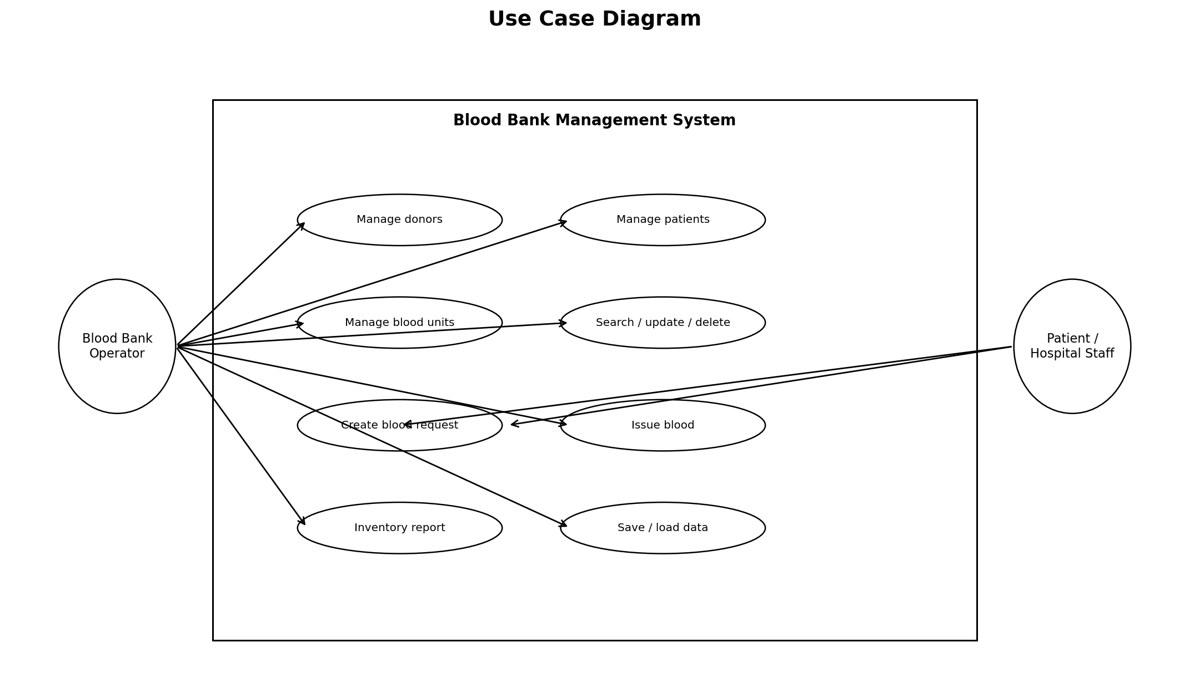

9.2 Class Diagram
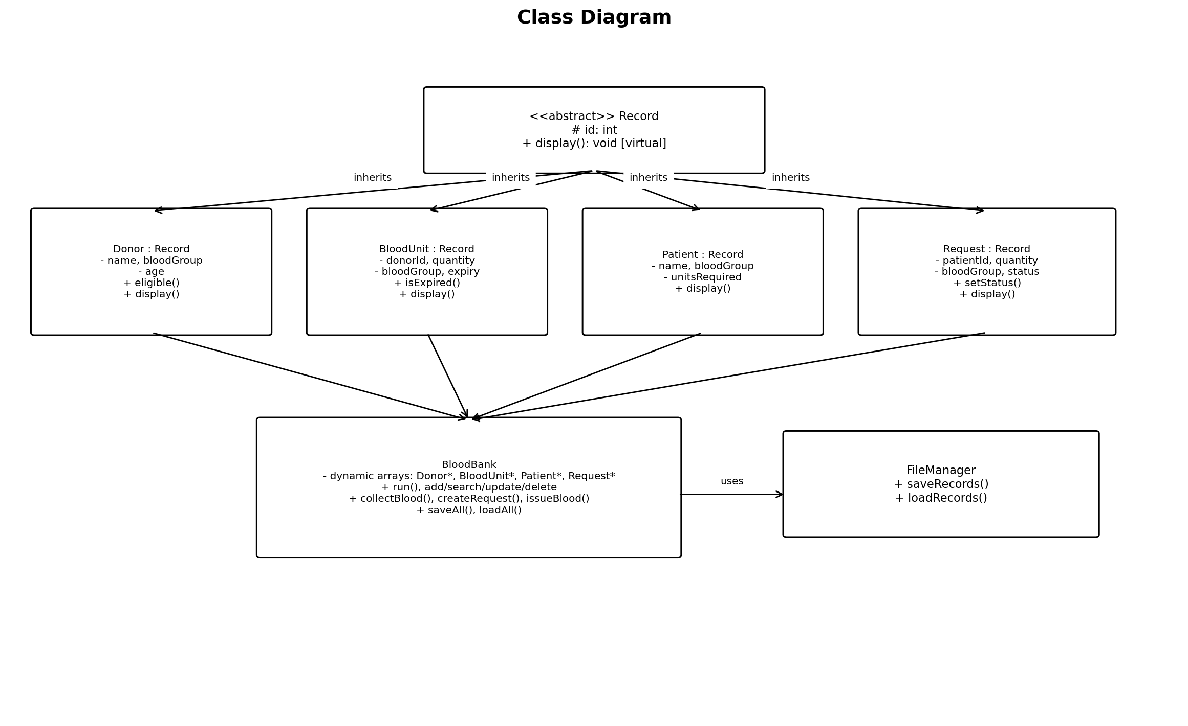
9.3 Sequence Diagram 1 — Issue Blood
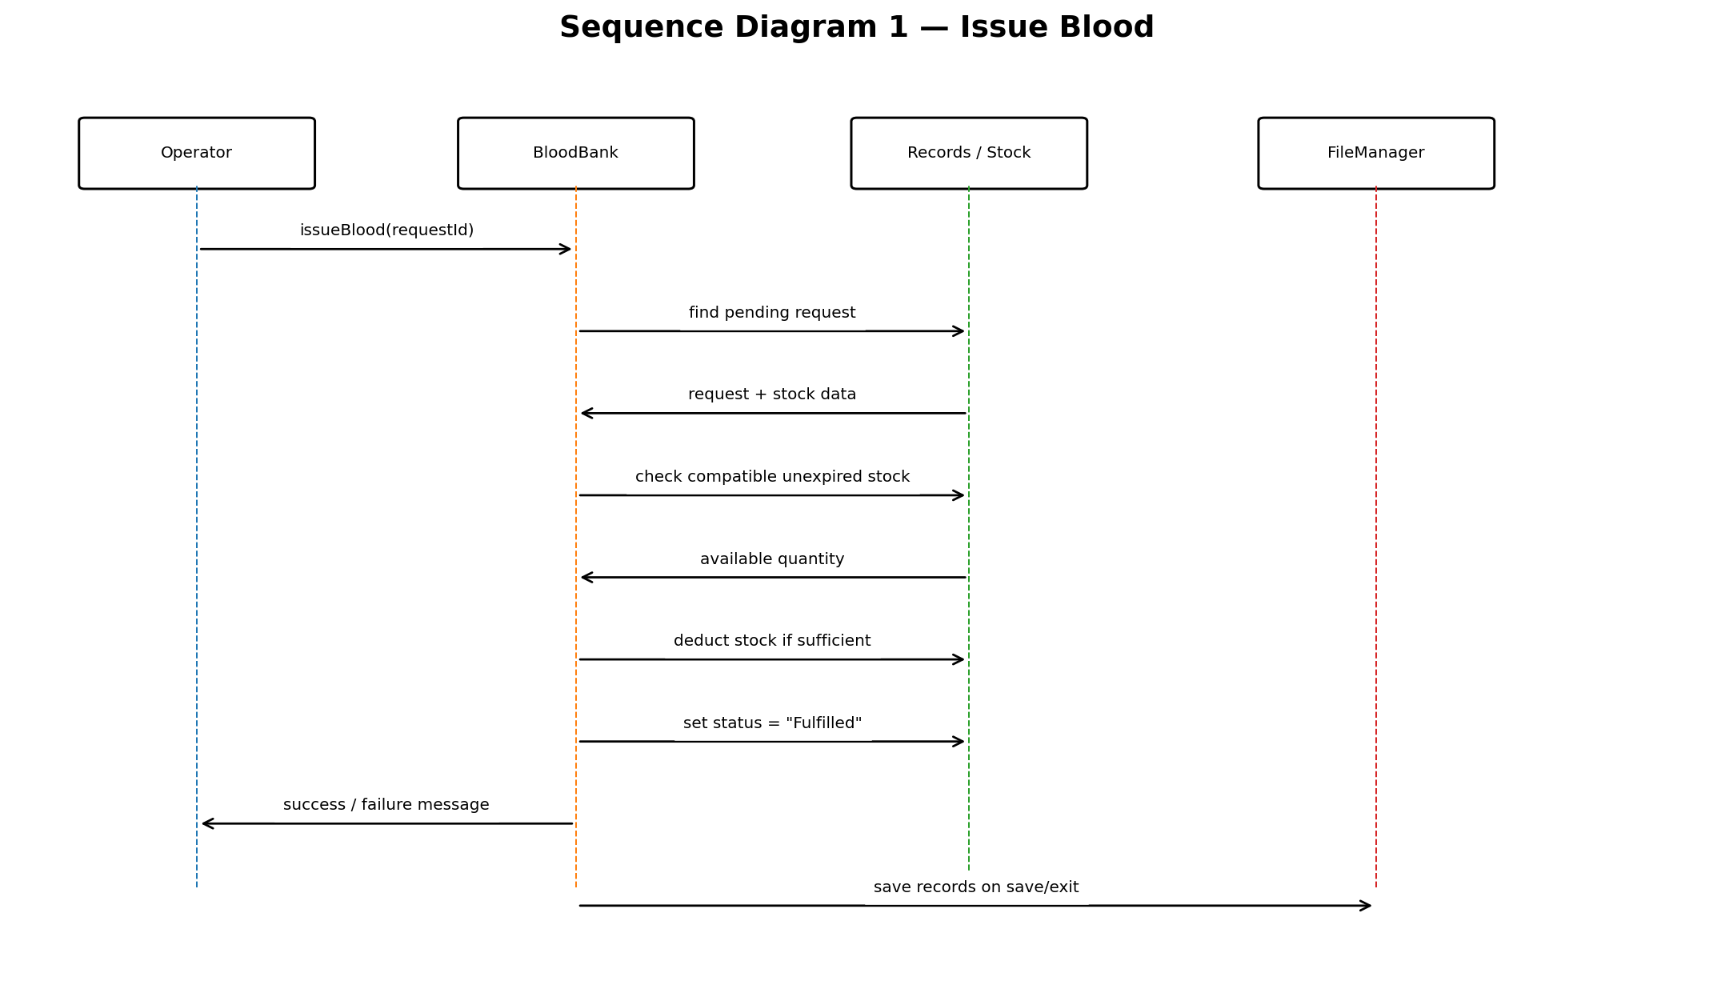

9.4 Sequence Diagram 2 — Collect Blood
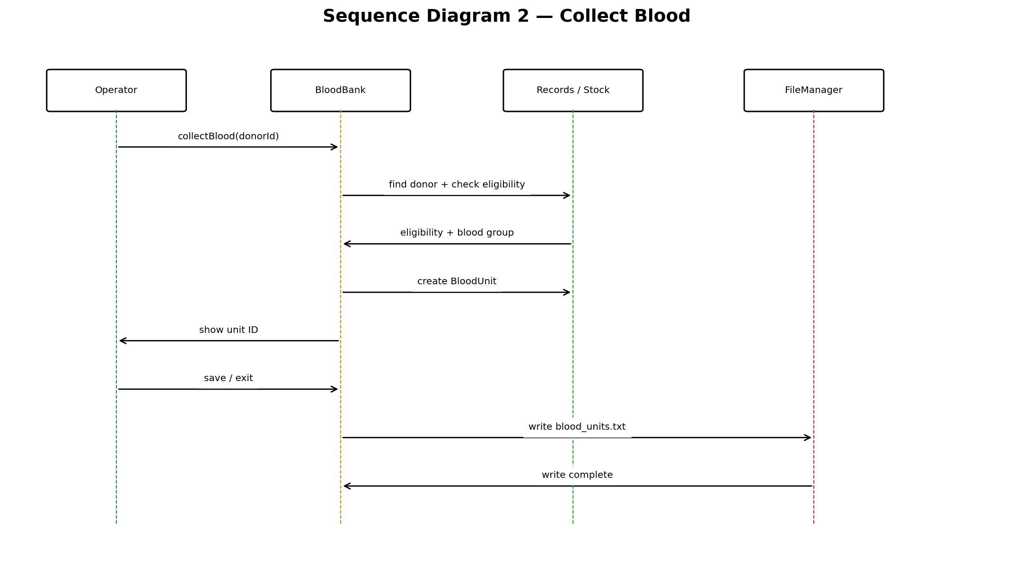

10. Implementation Details

The implementation is written in standard C++ and organized in main.cpp for compilation. The main() function creates a Blood Bank object and starts its menu loop. Blood Bank coordinates the domain objects and File Manager. Dynamic arrays grow by allocating a larger array, copying existing records and releasing the previous array. Input helpers validate numeric ranges, text fields and blood groups. Blood stock is deducted only after a request's entire required quantity is found among matching unexpired units.
Date strings use the YYYY-MM-DD format. The expiry comparison is lexicographic, which works for correctly formatted ISO dates. The program checks the date's basic format but does not implement a full calendar-date parser.

11. Testing and Results

Test ID | Input / Operation | Expected | Actual | Status
T01 | Add donor | Name=Riya, age=25, blood group=O+ | Donor created with next donor ID | Pass
T02 | Add patient | Name=Patient A, blood group=A+, units=2 | Patient created with next patient ID | Pass
T03 | Invalid blood group | Enter X+ | Validation rejects it and asks again | Pass
T04 | Donor eligibility | Donor age=17; collect blood | Collection blocked as donor is ineligible | Pass
T05 | Collect blood | Eligible O+ donor; quantity=3; future expiry | Blood unit record created | Pass
T06 | Create request | Existing patient; quantity=1 | Request created with Pending status | Pass
T07 | Fulfill available request | Matching unexpired stock >= requested quantity | Stock decreases and request becomes Fulfilled | Pass
T08 | Insufficient stock | Request more matching units than available | Request remains Pending; stock unchanged | Pass
T09 | Expired stock | Matching unit expiry before current date | Expired stock excluded from available inventory | Pass
T10 | Search existing donor | Choose donor and valid ID | Matching donor is displayed | Pass
T11 | Search missing record | Choose any type and unused ID | Record not found message | Pass
T12 | Update patient | Existing patient ID; enter new details | Patient details are updated | Pass
T13 | Delete request | Existing request ID | Request removed from in-memory records | Pass
T14 | Persistence | Save, close, reopen application | Previously saved records load again | Pass
T15 | Invalid menu input | Enter letters or number outside 1-9 | Input is rejected and prompt repeats | Pass

12. Sample Screens / Output

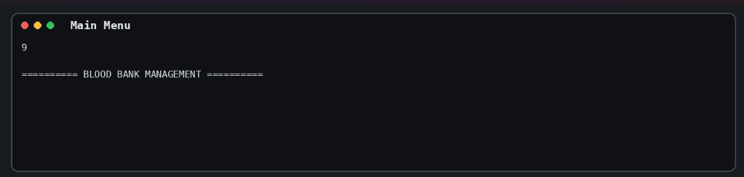
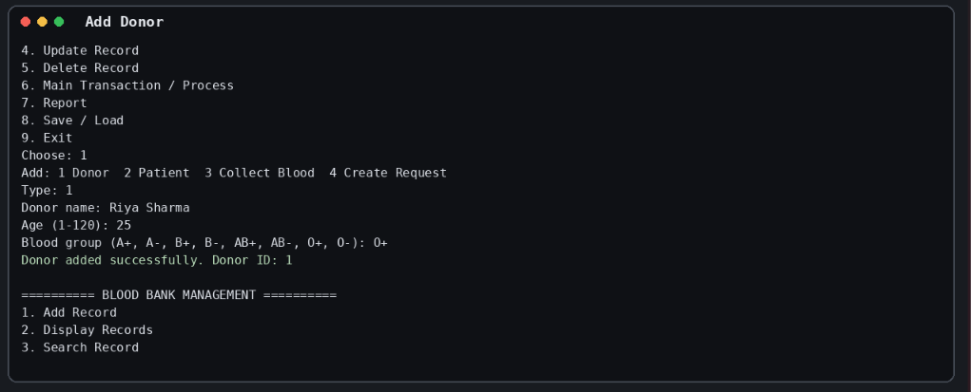
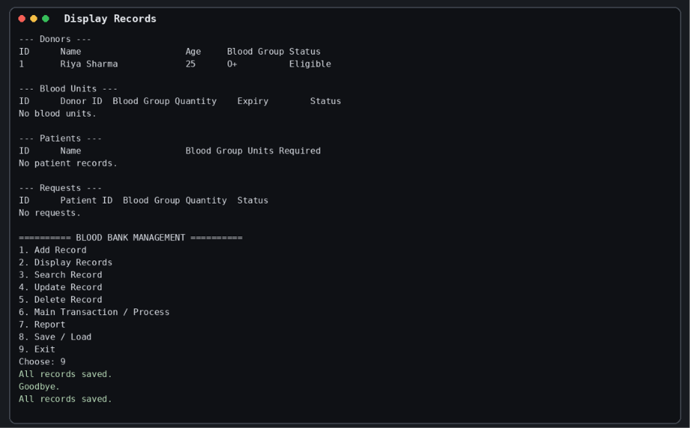
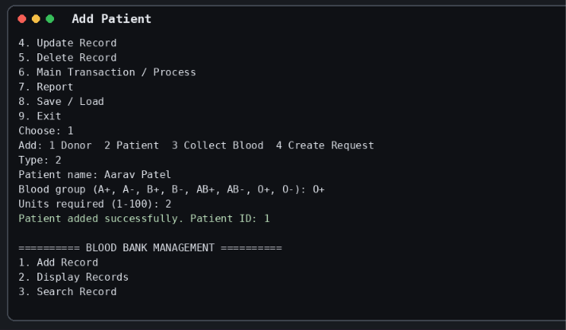
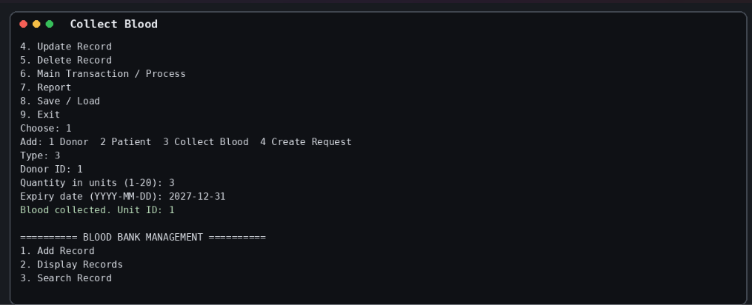
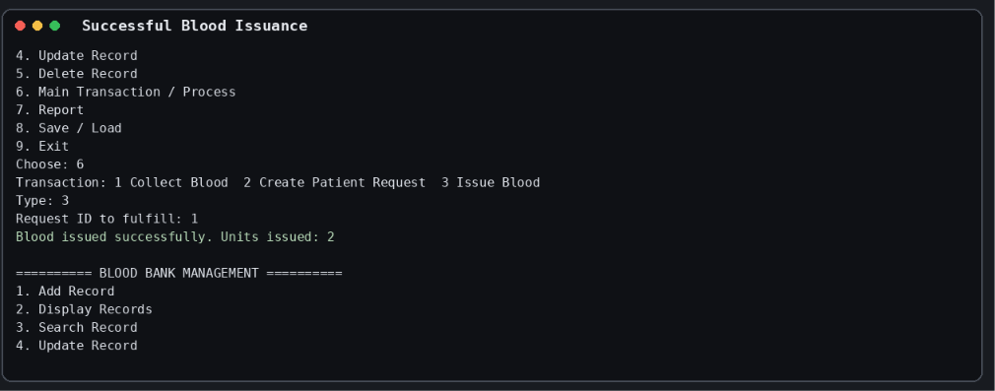
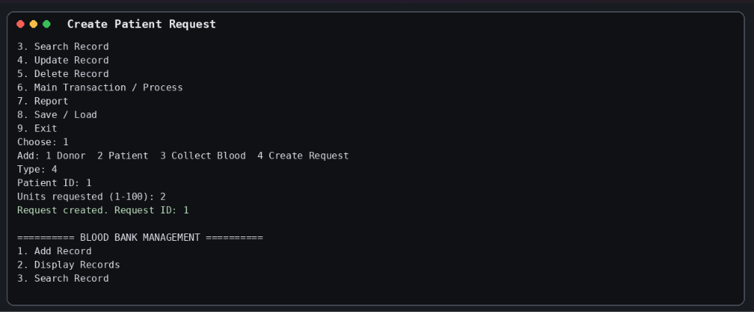
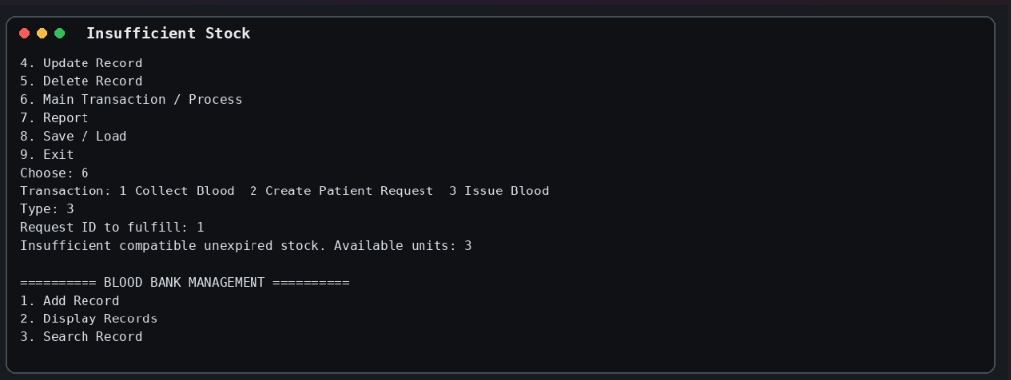
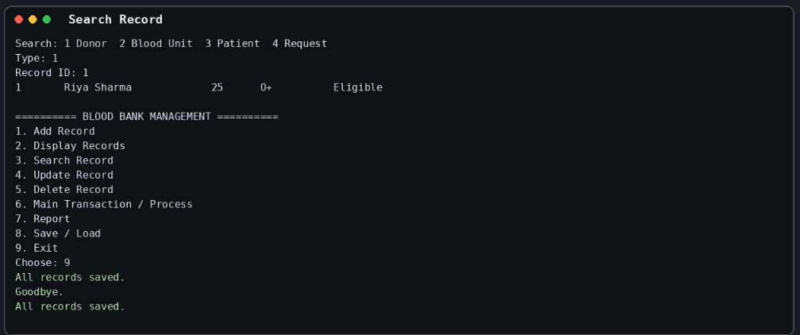
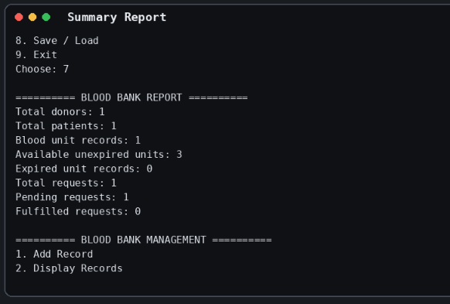
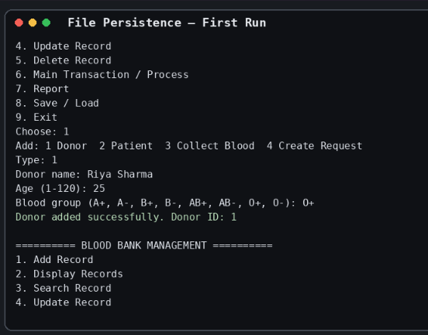
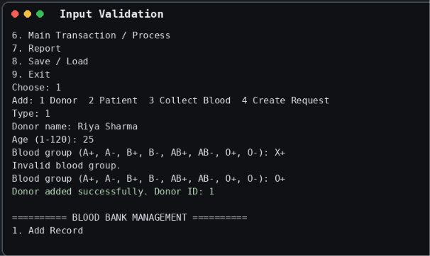
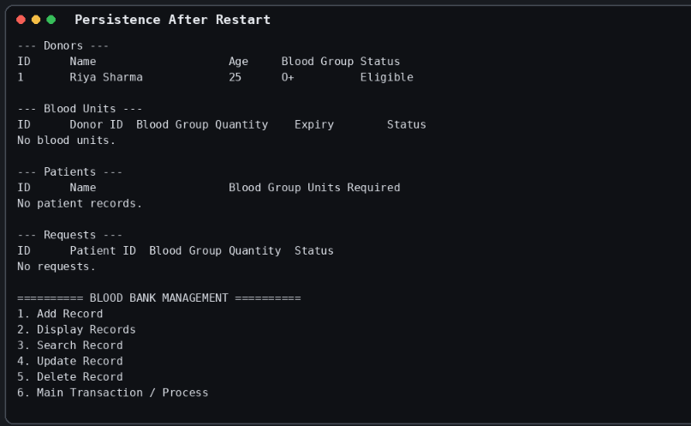

13. Limitations

- Console interface only; no graphical interface or user authentication.
- Blood compatibility is simplified to exact blood-group matching and is not a medical compatibility algorithm.
- No laboratory screening, cross-matching, donor history, hospital integration or regulatory workflow.
- Text files are suitable for demonstration but not for multi-user or production use.
- Expiry input validation checks ISO-like format and string order rather than validating every calendar date.

14. Future Scope

- Add a database such as MySQL or SQLite and transaction-safe updates.
- Add role-based login, audit logs and secure handling of personal information.
- Introduce complete calendar validation, stock batch tracking and notifications before expiry.
- Add advanced search, filters, blood-group inventory charts and exportable reports.
- Use medically reviewed compatibility rules only under qualified institutional supervision.

15. Conclusion

The Blood Bank Management project demonstrates how a menu-driven C++ program can organise donors, patients, blood inventory and requests. It applies core OOP concepts and basic file persistence while providing validation and a stock-issue workflow. Before submission, the student should compile the code, execute all test cases, capture real screenshots, complete personal details and verify that they can explain every class and function.

Github repository link : https://github.com/PalashPanchal08/Blood-Bank-Management-C-project

